|  |  |  |  |
| --- | --- | --- | --- |
|  | | |

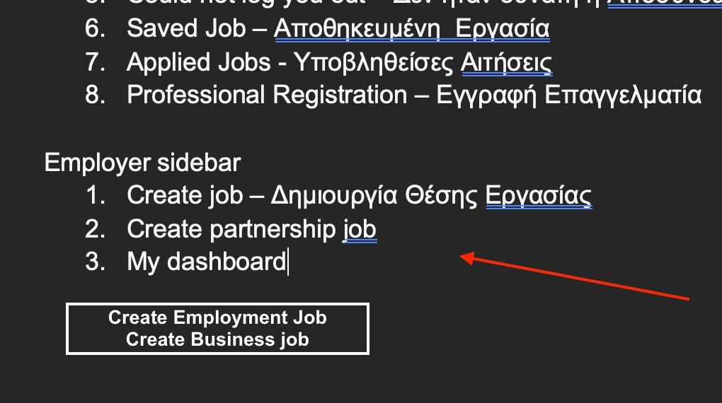

**Done(20240110): We have replaced these titles.**

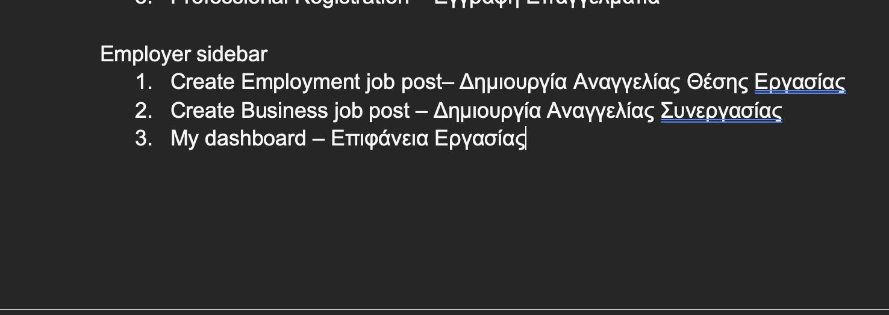

**Clarification(20240110): We need a shorter translation of these.**

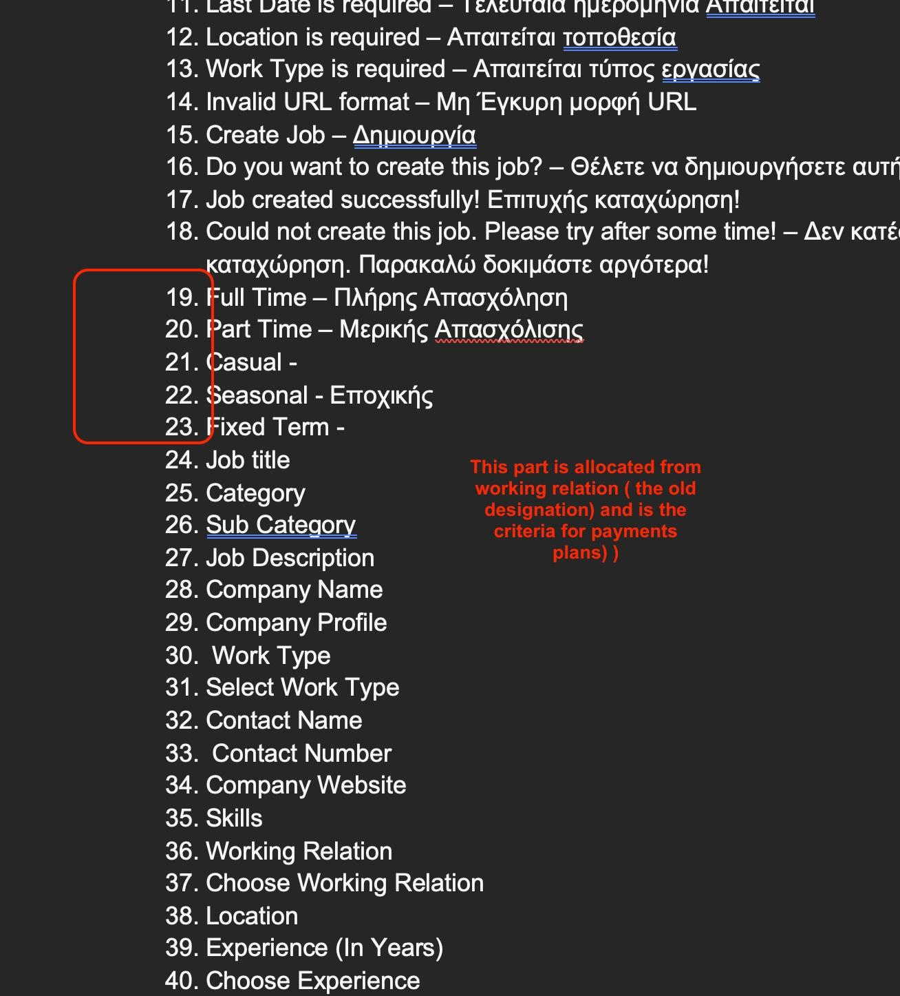

**Clarification(20240110): This is a customization work and requires extra time and effort.**

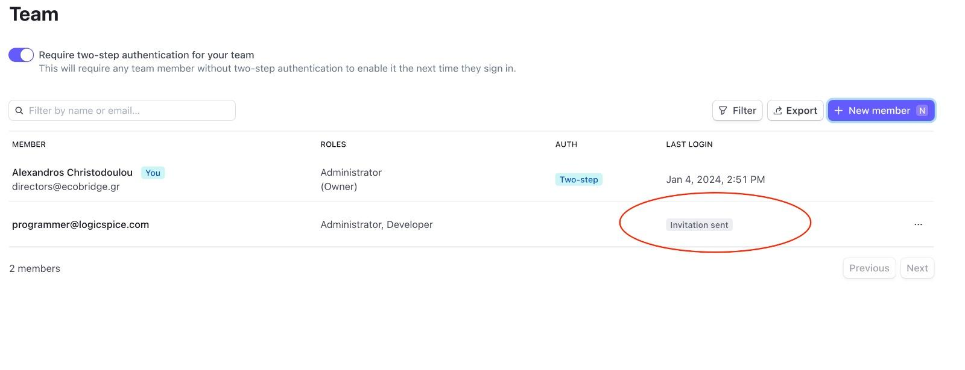

**Clarification(20240110): We are working on it. We will let you know once we complete it.**

also in 30 minutes you will be editor in figma

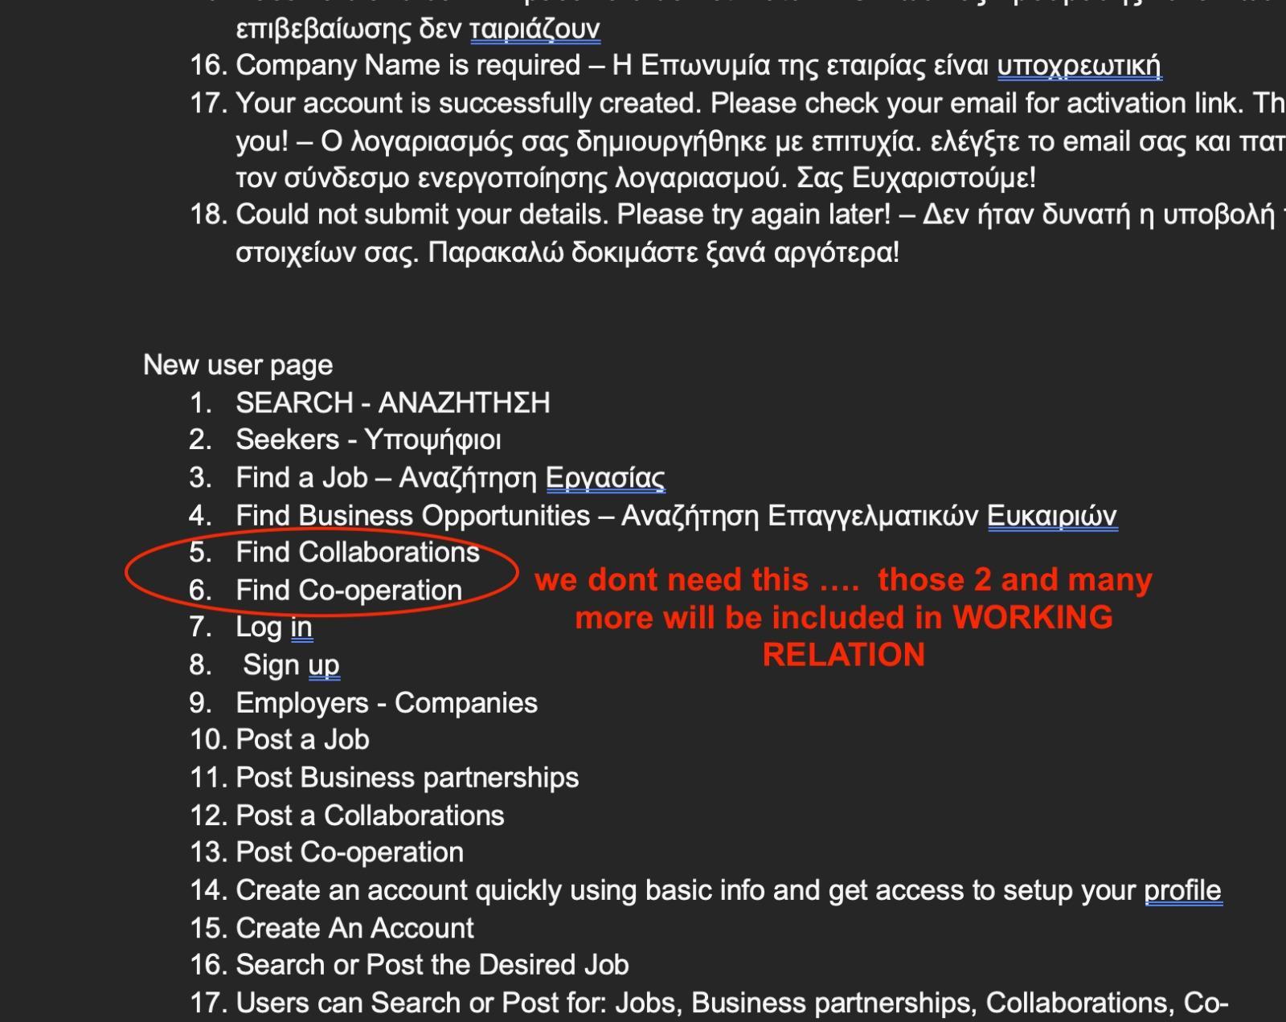

**Done(20240110): We have removed them from the home page.**

1 FIND JOB

2 FIND BUSINESS OPORTUNITY

When searching for job they will see all jobs with employment WORKING RELATION

ex full time , part time, etc

When searching for Business Oportunity they will see all posts with Business WORKING RELATION

ex. Partnership, franchise, cooperation, etc etc

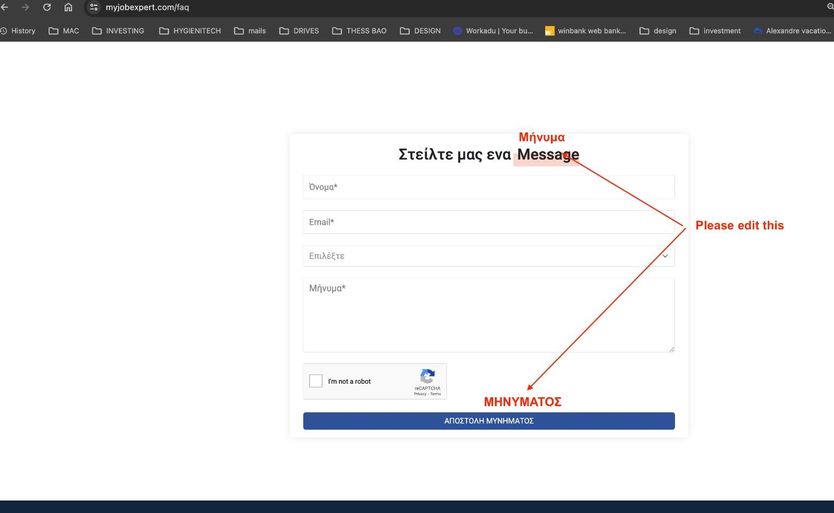

**Done(20240110): We have changed the translations. Next time when you want us to change any translation, please provide these translated text in a text file.**

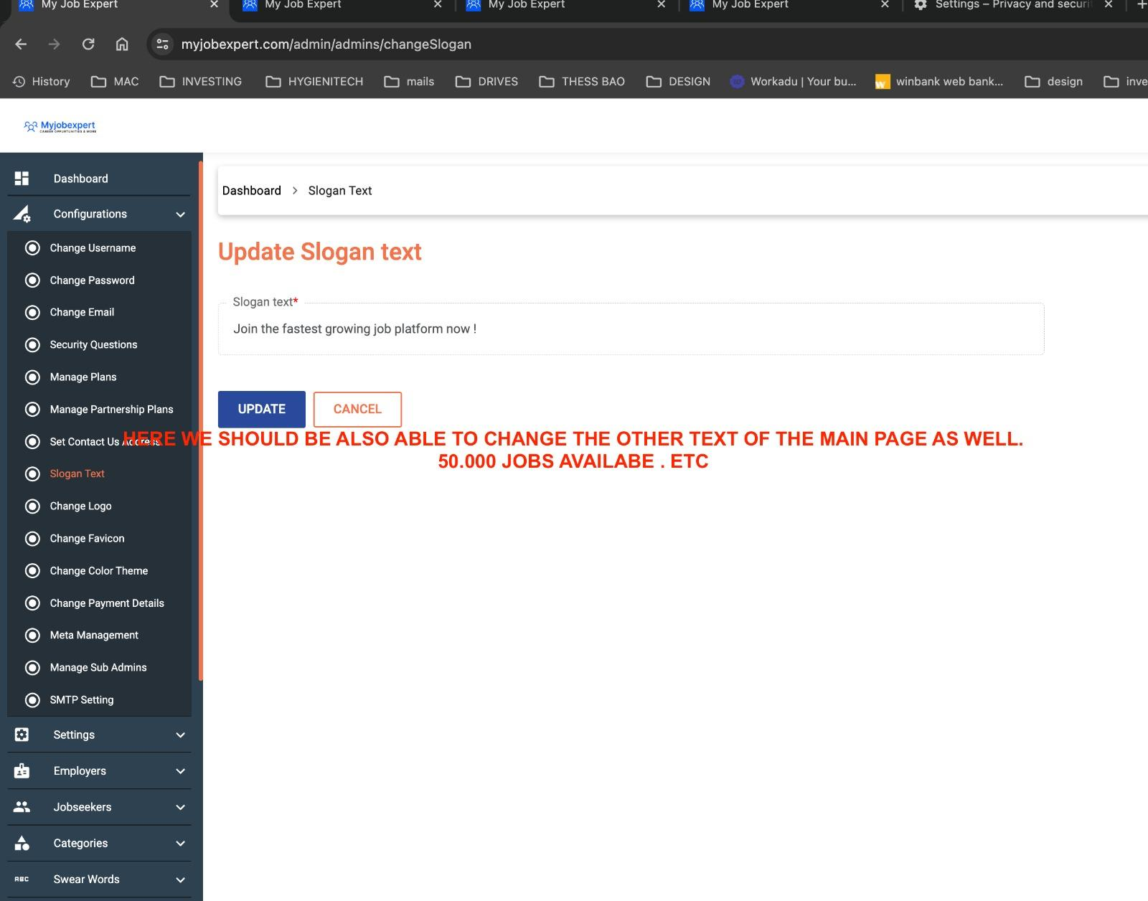

**Clarification(20240110): We are working on it. We will let you know once we complete it.**

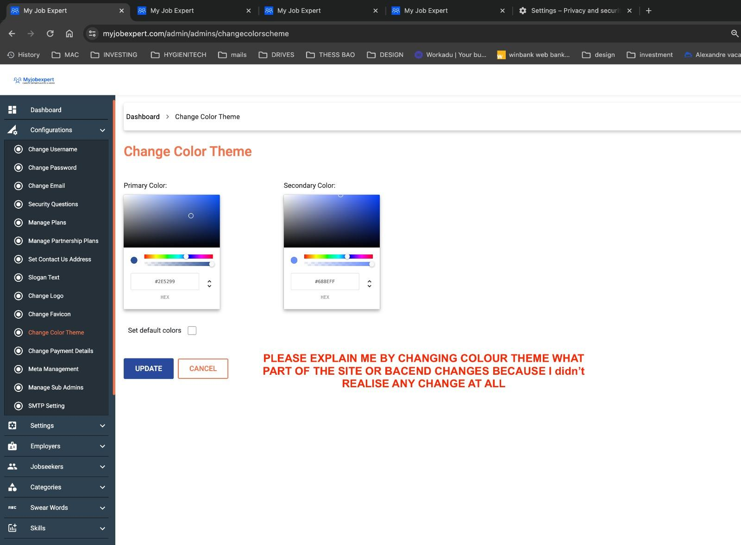

**Clarification(20240110): When you change the theme color from here, the elements of the frontend of the website that includes the UI, the entire employer side and the entire jobseeker side will be changed. The elements whose color will be changed includes, buttons, links, elements that can be hovered.**

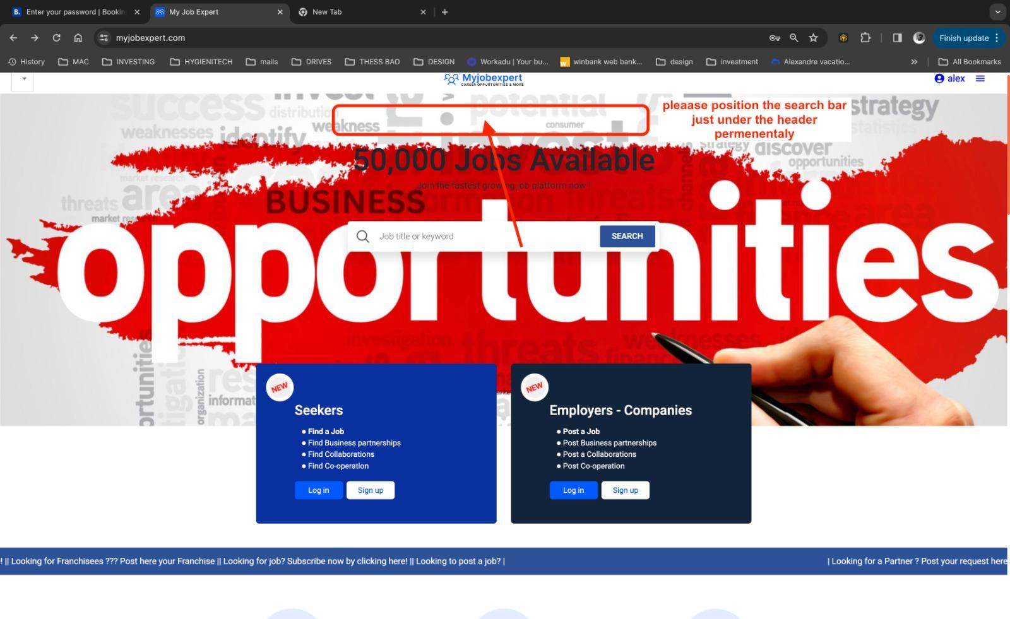

**Done(20240110): We have placed the search bar at the top of the website. Please check and confirm with us.**

we need to make the logo little bit bigger .. its too small . also in mobile the logo on the header is not displayed

**Done(20240110): We have increased the size of the logo. Please check and confirm with us.**

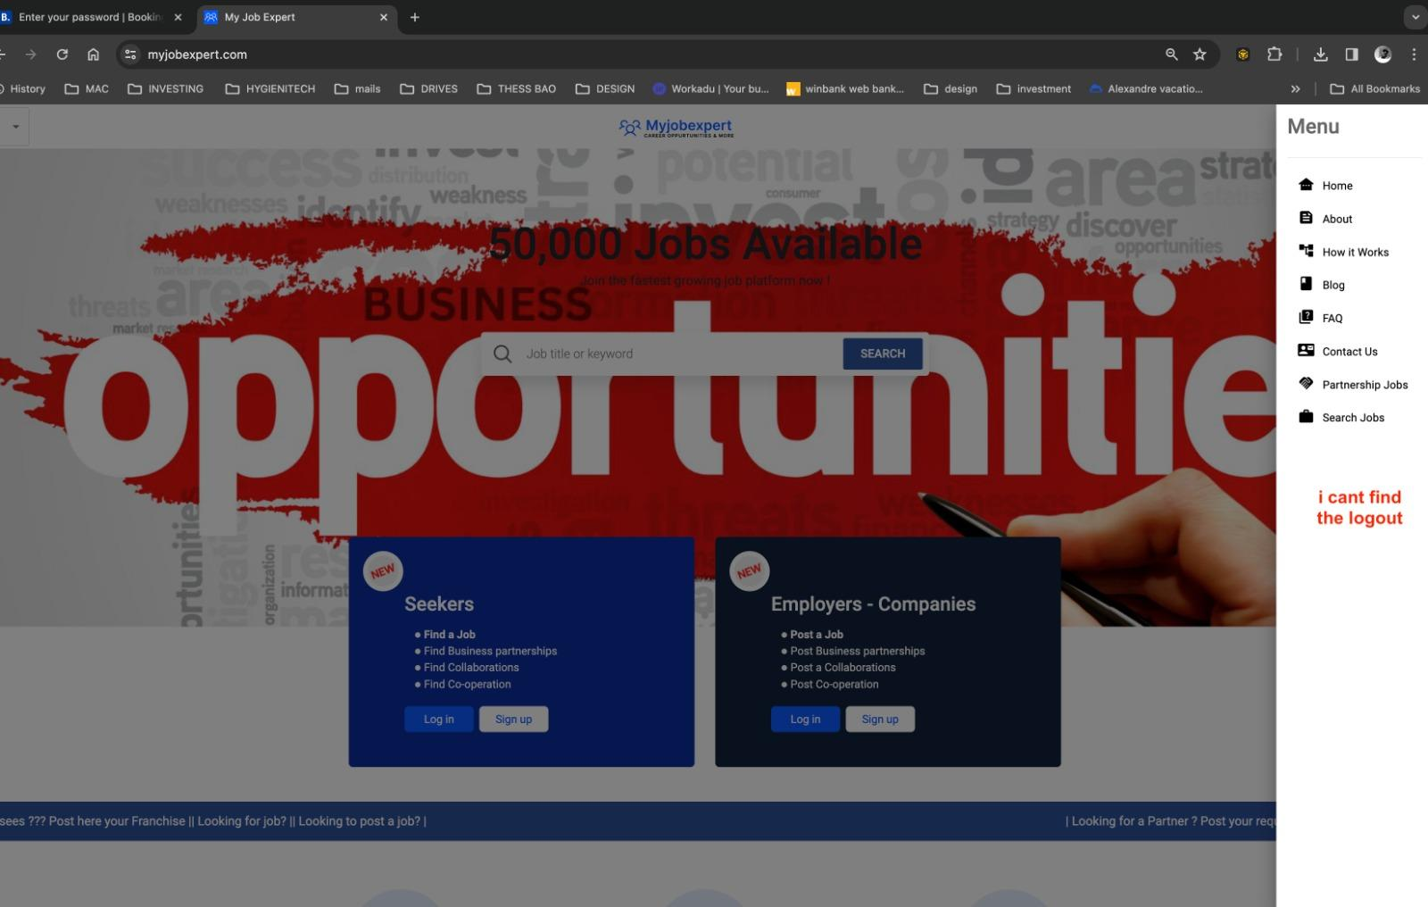

**Done(20240110): We have included a profile or account navigation button and a logout button on the sidebar and these will only be visible when you are logged in as an employer or as a jobseeker.**

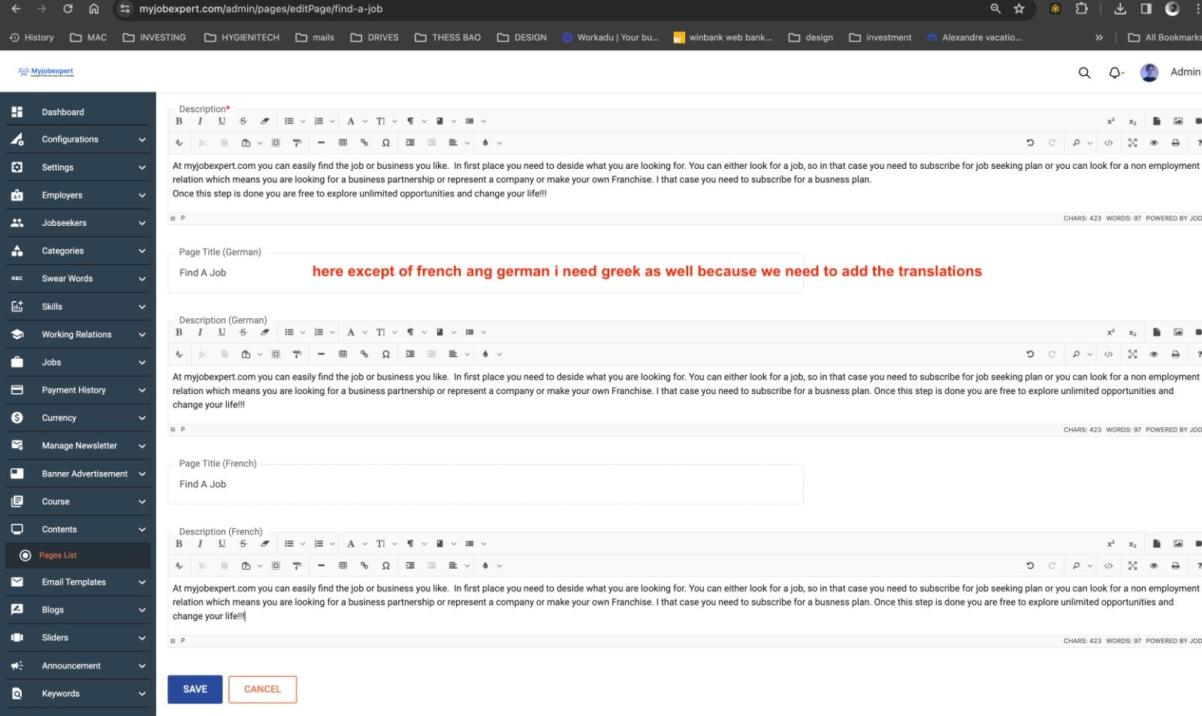

**Clarification(20240110): This is a customization work and requires extra time and effort. We have already discussed about it.**

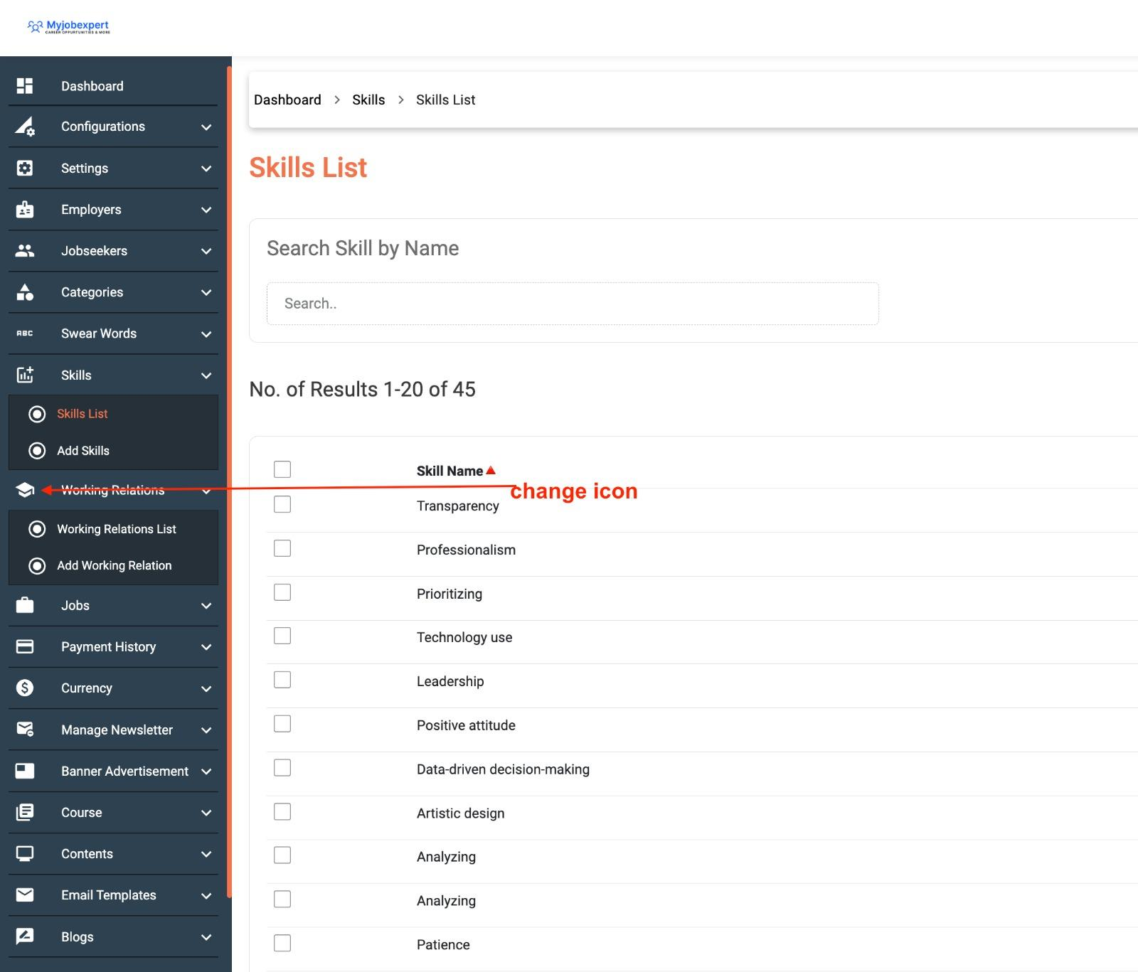

**Done(20240110): We have changed the icon. Please check and confirm with us.**

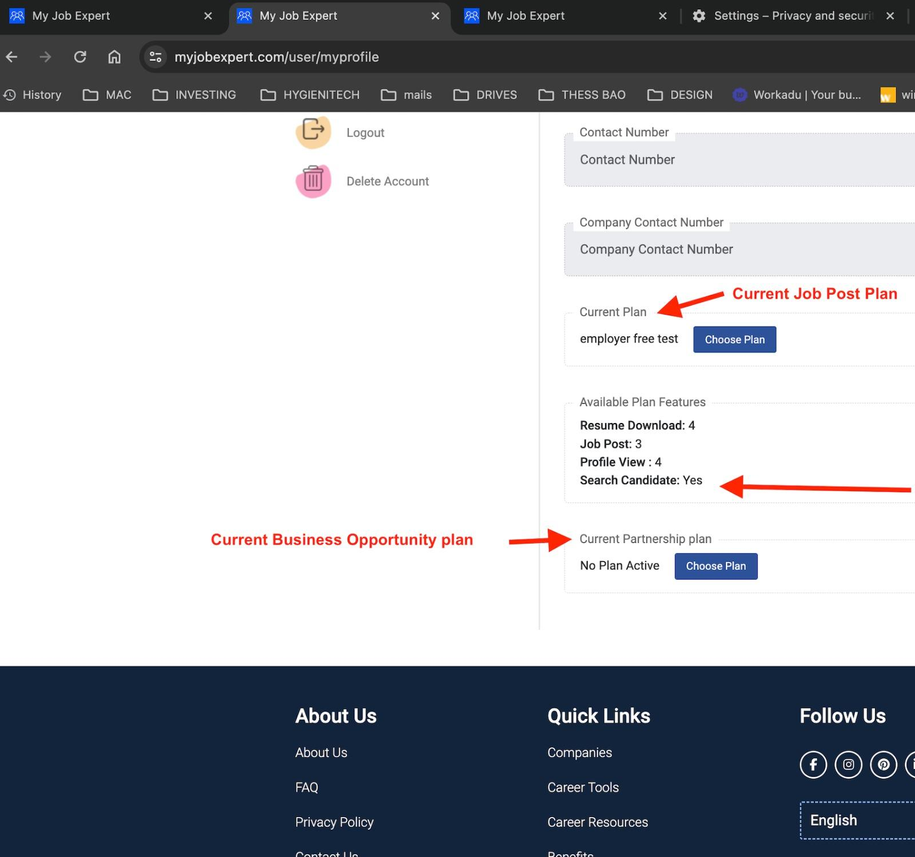

**Done(20240110): We have replaced these text with the text that you have provided.**

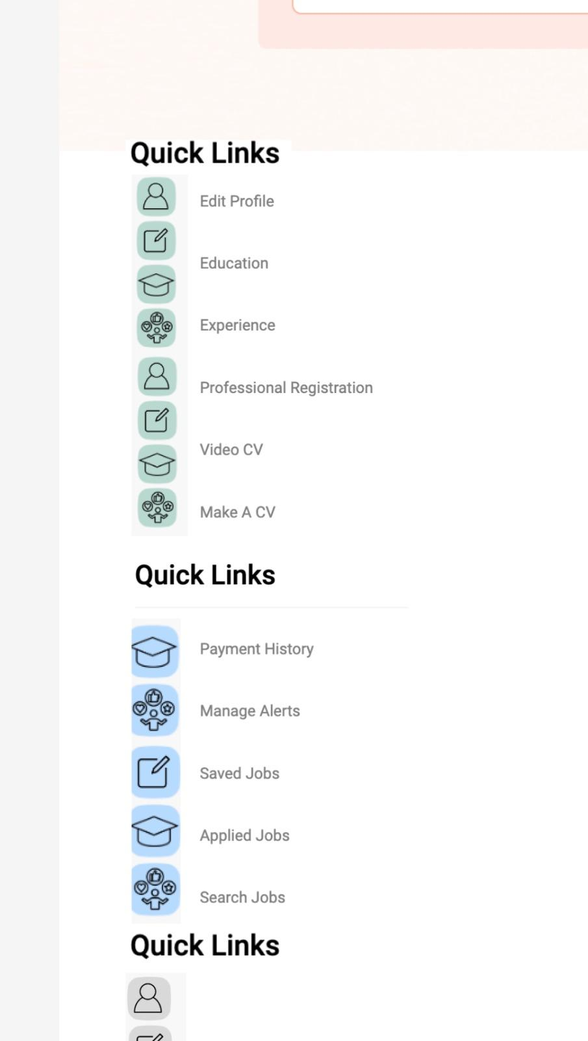

**Clarification(20240110): This is a customization work and requires extra time and effort.**

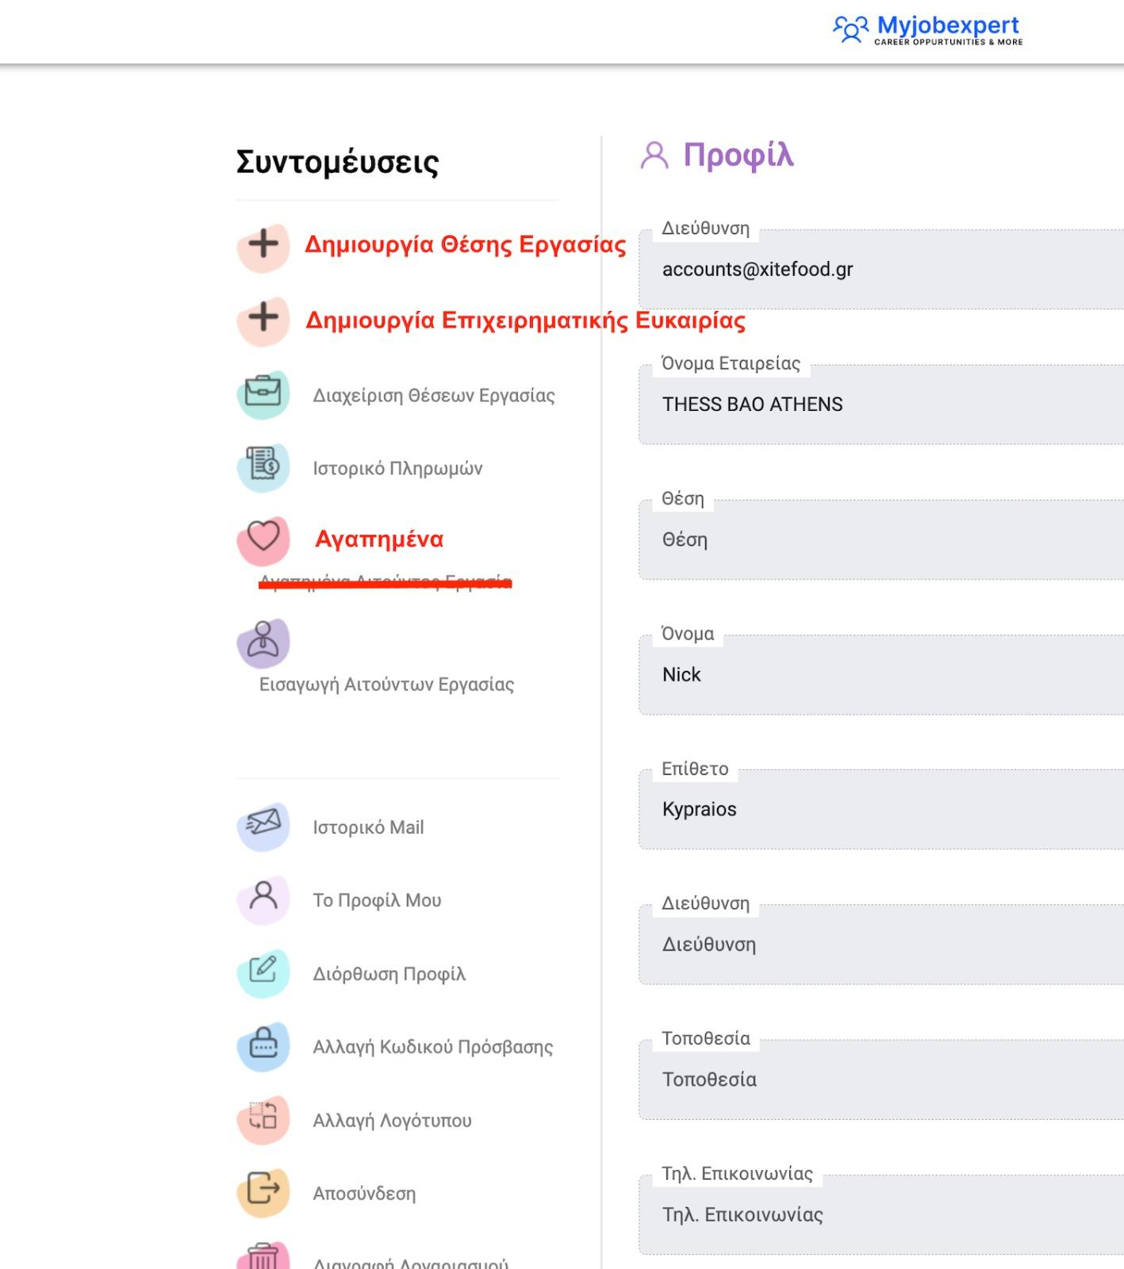

**Clarification(20240110): As discussed in the last meeting, please provide us a shorter name for the side bar, or else it will hamper the design of the sidebar. And while providing it, please write the total string so that we can identify it and put it on the correct place.**

**For example: when you provide the shorter translation of create employment job, write it this way:**

**Create employment job: (Translation here).**

**We need shorter name for the following:**

1. **Create employment Job**
2. **Create Business Job**
3. **Favourite List**
4. **Import Jobseekers**



**Done(20240110): We have replaced the text. Please check and confirm with us.**

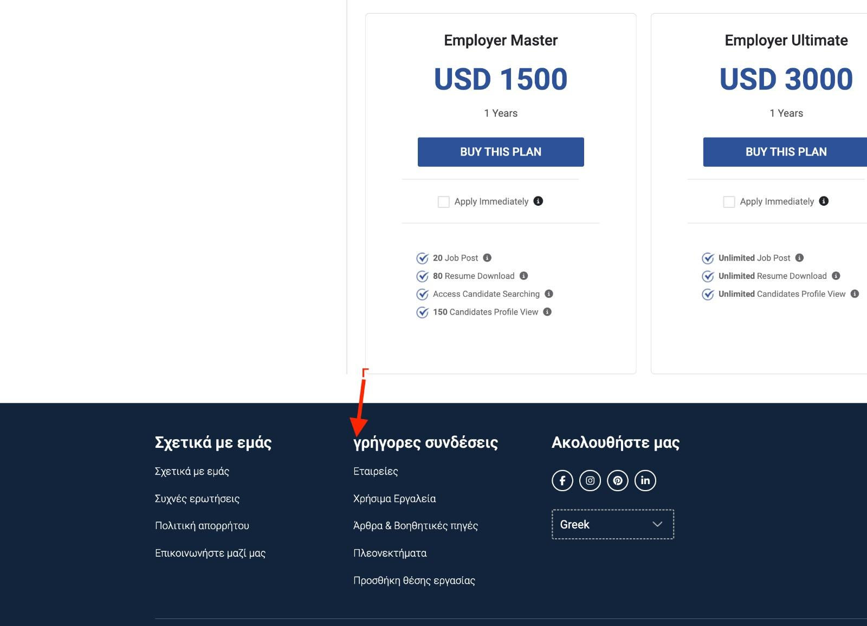

**Clarification(20240110): Please provide the total text as we can replace just a letter.**

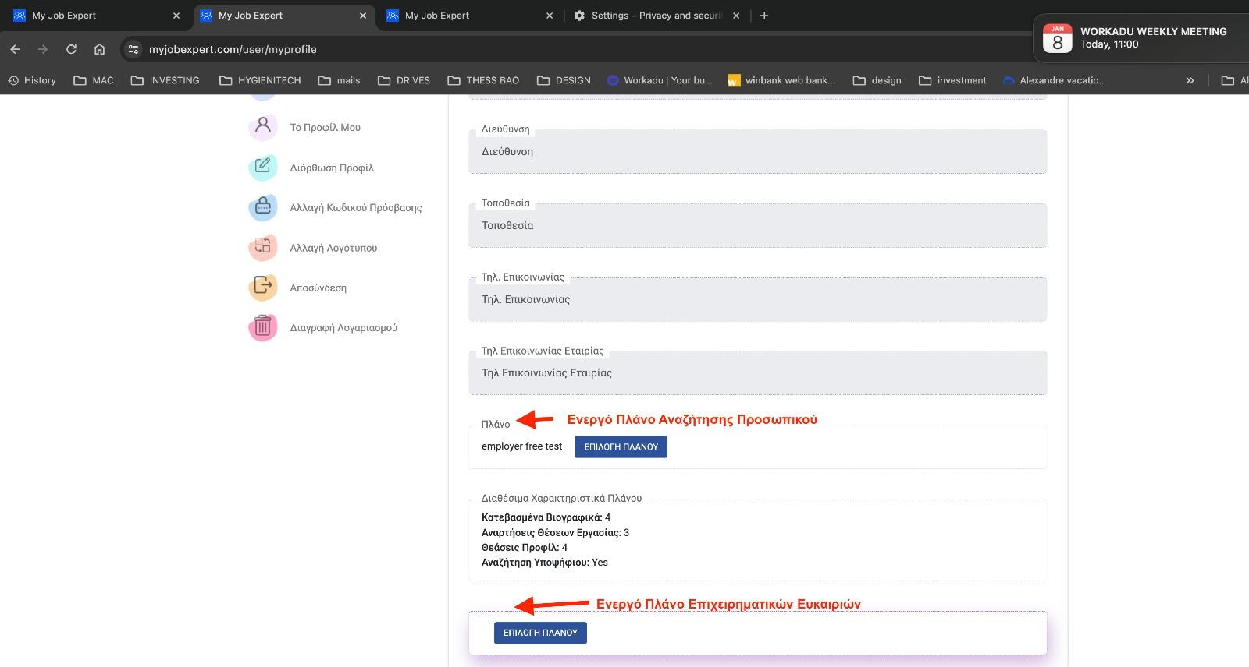

On the mobile website the logo is not shown at all on the top

Thats a screenshot from mobile.. no logo and the search bar to wide

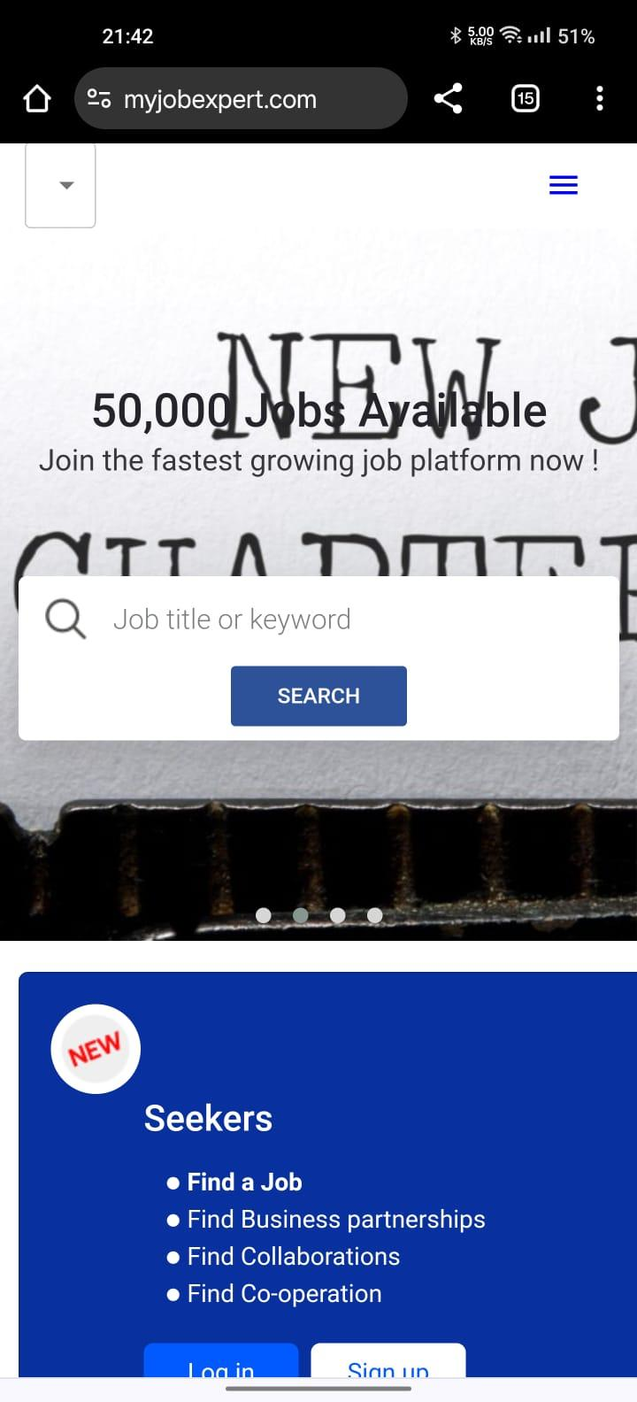

**Done(20240110): Since in the mobile design in figma, the logo was not present so we removed it. But now we have made it visible. Please check and confirm with us.**

**Changes discussed in the last meeting:**

1. Logo of the navigation bar should be bigger

**Done(20240110): We have increased the size. Please check and confirm with us.**

1. Logout button should be there on the sidebar

**Done(20240110): We have added the button. Please check and confirm with us.**

1. The slider heading should be manage able from admin panel.

**Clarification(20240110): We are working on it. We will let you know once we complete it.**

1. Banner advertisement position should be customized from admin panel.

**Clarification(20240110): This is a customization work and requires extra time and effort.**

1. Data at the About us page bottom cards should be dynamic and should be changed from admin panel.

**Clarification(20240110): We are working on it. We will let you know once we complete it.**

1. Create Job should be renamed to Create Employment Job

**Done(20240110): We have renamed this. Please check and confirm with us.**

1. Create Partnership Jo should be renamed to Create Business Opportunity.

**Done(20240110): We have renamed this. Please check and confirm with us.**

1. Working Relation should be placed on the top in create employment job and create business job pages.

**Clarification(20240110): We are working on it. We will let you know once we complete it.**

1. In add/edit working relation pages, a separate selection box should be there which classifies the working relation to be under employment job or business job.

**Clarification(20240110): This is a customization work and requires extra time and effort.**

1. In working relation index page, a separate colume should be there, which shows the working relation type beside each record.

**Clarification(20240110): This is a customization work and requires extra time and effort.**

1. When Jobseeker logins, he/she should be initially navigated to search employment job page.

**Done(20240110): We have changed the navigation path. Please check and confirm with us.**

1. When jobseeker logins, the search job box should be there at every page jobseeker navigates.

**Clarification(20240110): This is a customization work and requires extra time and effort.**

1. The icons of the side of the employer and jobseeker should be changed.

**Clarification(20240110): This is a customization work and requires extra time and effort.**